Exercise 6:
Library Management System

1.Understand Search Algorithms:

linear search and binary search algorithms.
Linear Search:
This approach starts at the very first book on the shelf and checks each book one-by-one until it either finds a title match or reaches the end of the shelf. It does not require the books to be organized in any specific order.
Binary Search:
This approach is much smarter but relies on a strict condition: the books must be sorted alphabetically by title. It checks the exact middle book on the shelf. If the target title comes alphabetically before the middle book, it completely discards the right half of the shelf. It repeats this halving process until the book is found.

2. Setup:

We will implement this in Java. Create a file named Book.java. Create Library.java to contain the search algorithms, and Main.java to test them. for Binary Search we use Java's compareToIgnoreCase() to evaluate alphabetical ordering
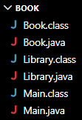

3.Implementation:
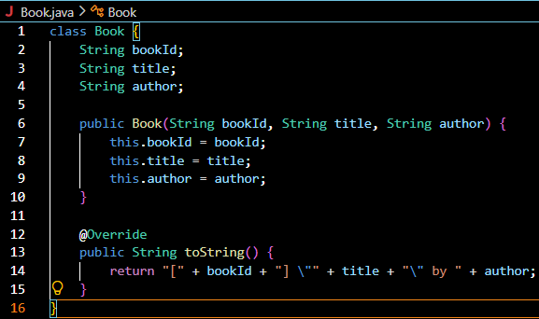
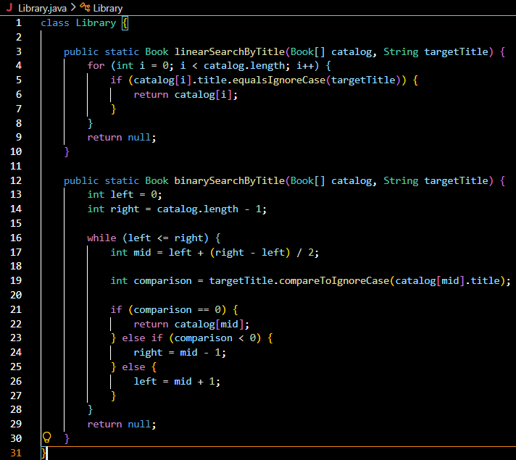
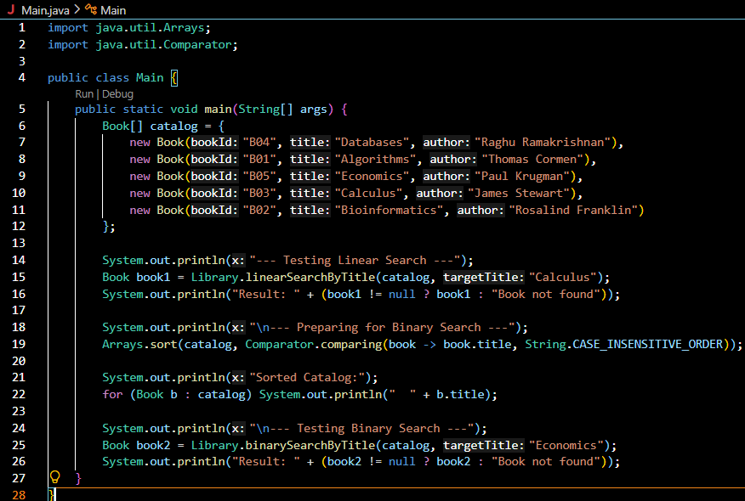
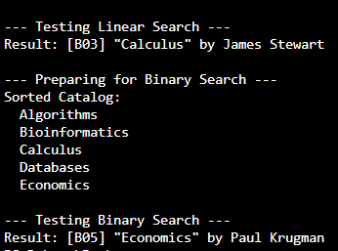

4.Analysis:
Algorithm Best-Case Average-Case Worst-Case (Big O)
Linear Search O(1) O(n) O(n)
Binary Search O(1) O(log n) O(log n)
Linear vs. Binary Search
Linear Search (O(n)): In a small library of 100 books, checking each one individually is trivial. But if you scale up to a metropolitan library system containing 1,000,000 titles, a worst-case search means performing 1,000,000 comparisons, which wastes processing cycles.
Binary Search (O(log n)): Because it cuts the data set in half with every single check, searching through that same system of 1,000,000 books takes a maximum of just 20 comparisons.
Use Linear Search When:
- The dataset is small: For instance, a user's personal favorites list. The performance difference between O(n) and O(log n) at small scales is completely unnoticeable.
- The dataset is unsorted and changes constantly: Sorting an unsorted array takes time (O(n log n)). If your application adds and changes records continuously but rarely handles searches, it is computationally cheaper to perform a simple linear search than to repeatedly sort the entire database.
Use Binary Search When:
- The dataset is large: For example, enterprise inventory catalogs or massive digital databases.
- The dataset is stable and static: If books are rarely added but searched millions of times a day by users, sorting the catalog once allows you to reap the massive performance rewards of lightning-fast O(log n) binary lookups indefinitely.

